**Joaquin Emilio Weiss y Sánchez (1894, Havana - 1968, Havana), Architect, Historian**

Modern Architecture in Cuba cannot be fully understood without acknowledging the strong tradition of historicism in the development of the discipline throughout the first half of the twentieth century. Although not the first individual to teach architectural history in Cuba, Joaquin Weiss was nevertheless the first to publish historical texts from a Cuban perspective for use in education, and one of the most important individuals to advocate a legitimizing role of local architectural tradition in the development of a national modernity.

Joaquin Weiss commenced his architectural training at Cornell University, graduating in 1916. After briefly practicing in the United States he returned to Cuba, joining architect Carlos Maruri in the creation of the firm Maruri y Weiss. He eventually expanded his practice into the then fairly novel practice of historical preservation and restoration, engaging in projects in the colonial core of Old Havana. These interests prompted his membership in the Junta Nacional de Arqueología y Etnología (*National Board of Archeology and Ethnology*)as well as the Comisión Nacional de Monumentos (*National Commission of Monuments*)*.*

Weiss became an instructor of history at the School of Architects and Engineers at the University of Havana in 1928. At that time, the chair for the department of history was held by Alberto Camacho, a young architect and vocal proponent of the developing modern functionalist school of thought. Although supportive of historical studies that concerned Cuba’s architectonic patrimony, a pedagogical shift was imminent during Camacho’s tenure. His zealous attempts for Cuba to reach the forefront of an international rational modernity were cut short, however, with his premature death while en route to Europe in 1929. Weiss officially replaced Camacho as the history chair in 1930. Though less radical than his younger predecessor, Weiss nevertheless supported the concept of modernity and the need to reform Cuban architectural practices which at that time were heavily influenced by a false historicism and eclecticism born out of an early post-colonial search for formal identity. As a seminal figure in the revalorization of Cuba’s colonial architecture, a hybridized conceptualization for a Cuban modernity emerged during his tenure as chair. This school of thought sought to support the influence of traditional forms and language developing a modern regional vocabulary. Weiss held the chair in history until 1962, in the meantime serving as the Dean of the Department of Architecture from 1947 to 1953.

It is possible to view Weiss as a progenitor of a Cuban school of architectural historical thought. Although at times guilty of utilizing a descriptive language and historical method that sought to validate the development of Cuba’s architecture through comparison with a contemporary understanding of the Western Tradition, as is evident in *Resumen de la Historia de la Arquitectura* (*Summary of the History of Architecture,* 1942) and *Arquitectura de las Grandes Culturas* (*Architecture of the Great Cultures,* 1957), his approach nonetheless included the treatment of Latin American architectural traditions during a period when these were largely excluded from historical surveys and textbooks. In his conceptualization of modern Cuba’s most lasting architectural movements – the renewal of interest in colonial architectural language and the development of a contemporary means of expression – he offered two landmark texts: *Arquitectura Cubana Colonial* (*Colonial Cuban Architecture*, 1936) and *Arquitectura Cubana Contemporánea* (*Contemporary Cuban Architecture,* 1947).

Further Reading:

Weiss, Joaquín E. (1936) *Arquitectura Cubana Colonial,* Havana: Cultural S.A.

Weiss, Joaquín E. (1947)*Arquitectura Cubana Contemporanea,* Cultural S.A.

Zardoya, Maria Victoria (2008) “Joaquín Weiss in memoriam” *Arquitectura Cuba.*

<http://arquitectura-cuba.blogspot.com>

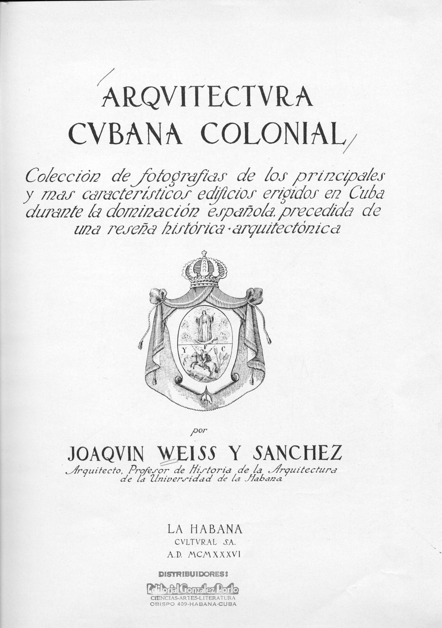

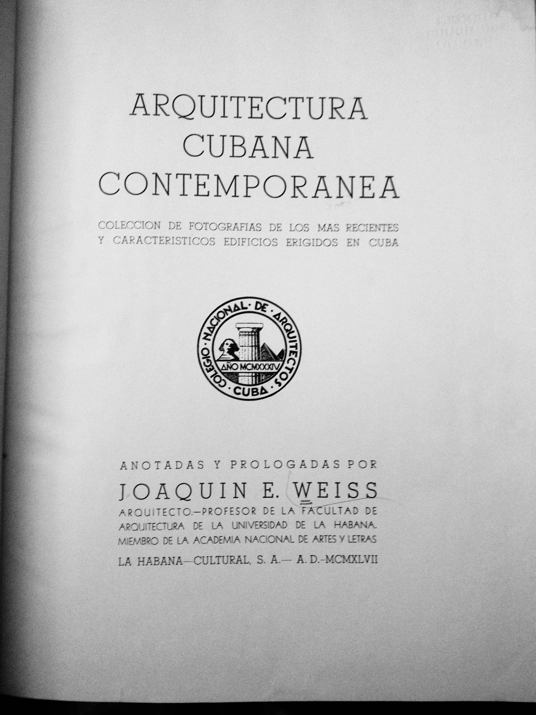

Left: Front page of *Arquitectura Cubana Colonial,* 1936. Right: Front page of *Arquitectura Cubana Contemporanea,* 1947.